Nested-Figure Composition

Definition
# Source: AI Source: Provided by: [Data Path: Persons Table -> ID Column: 1, Name_En Column: Motasem Essam] -> From: [ChatGPT] on [7/25/2026]
Nested-Figure Composition is a type of geometric figure composition in which one or more geometric figures are positioned entirely inside another geometric figure, creating an inner-and-outer arrangement.
The inner figure may be completely separated from the outer boundary, touch that boundary, or share a common center or other geometric feature with the outer figure.

Simple Definition
# Source: AI Source: Provided by: [Data Path: Persons Table -> ID Column: 1, Name_En Column: Motasem Essam] -> From: [ChatGPT] on [7/25/2026]
Nested-figure composition means placing one geometric figure inside another geometric figure.
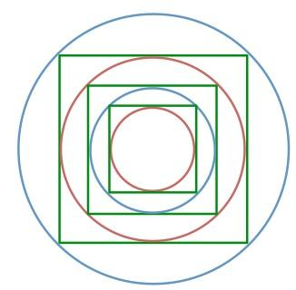
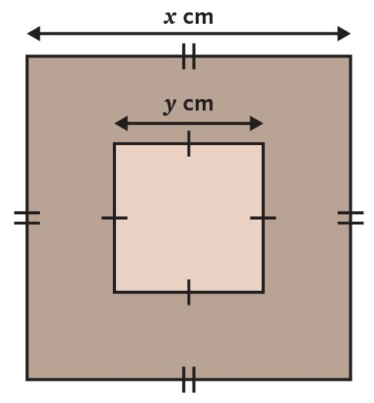
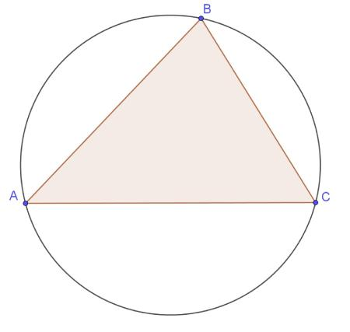

Main Classification
# Source: AI Source: Provided by: [Data Path: Persons Table -> ID Column: 1, Name_En Column: Motasem Essam] -> From: [ChatGPT] on [7/25/2026]
The following is a practical classification based on the positions and relationships of the inner and outer figures. These categories are descriptive rather than a universally standardized taxonomy, and some overlap.

1. Concentric Nested-Figure Composition
# Source: AI Source: Provided by: [Data Path: Persons Table -> ID Column: 1, Name_En Column: Motasem Essam] -> From: [ChatGPT] on [7/25/2026]
Two or more circular figures share the same center.
Example: Three circles with radii $2$, $4$, and $6$units, all centered at $O$.
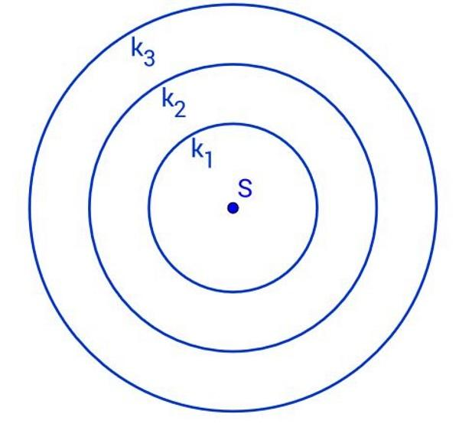
Detailed Explanation and Examples
Definition: Two or more circles share the same center but have different radii.
Example: Three concentric circles have radii $2$, $4$, and $6$units.
Their areas are
$$A_{1}=4π, A_{2}=16π, A_{3}=36π.$$
The region between the outermost circle and the middle circle has area
$$A=36π-16π=\boxed{20π}.$$
Concentric figures are especially useful in circle geometry, annular regions, and radial designs.

2. Centered Nested-Figure Composition
# Source: AI Source: Provided by: [Data Path: Persons Table -> ID Column: 1, Name_En Column: Motasem Essam] -> From: [ChatGPT] on [7/25/2026]
An inner figure is positioned centrally inside an outer figure.
Example: A smaller square centered inside a larger square.
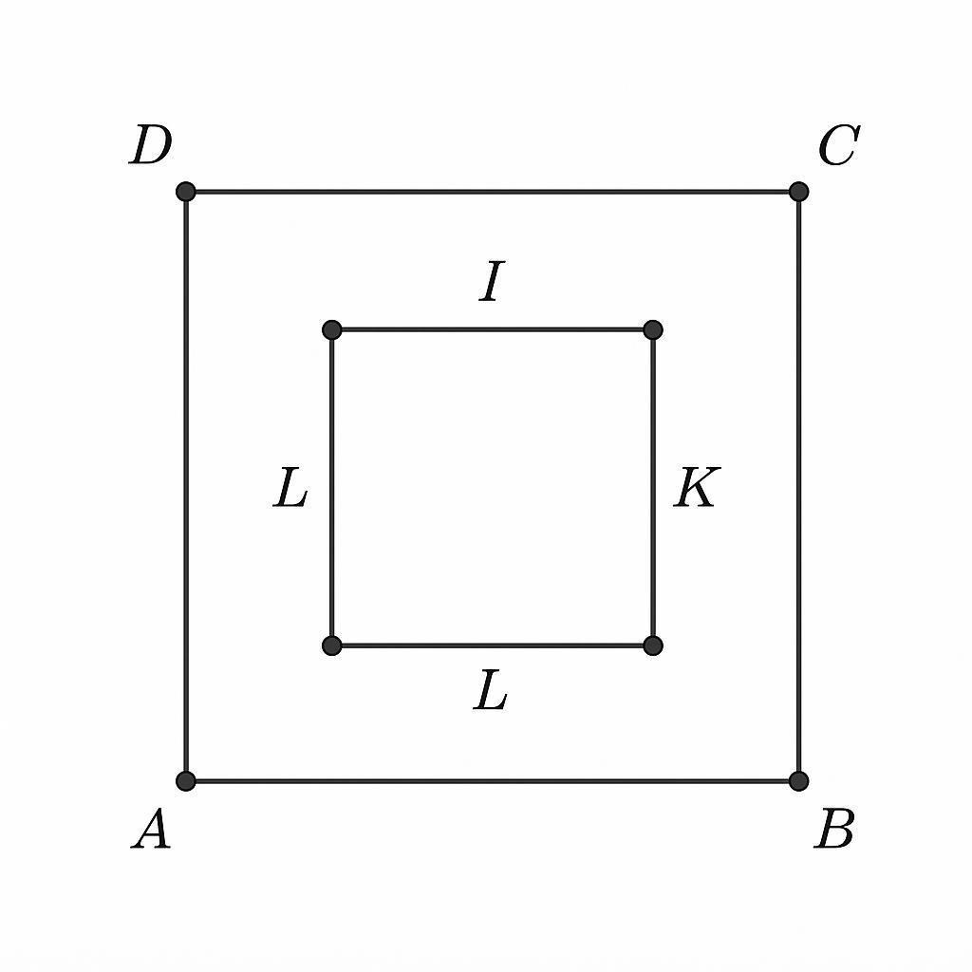
Detailed Explanation and Examples
Definition: An inner figure is positioned centrally within an outer figure according to a chosen center or symmetry arrangement.
Example: A square of side length $4$units is centered inside a square of side length $10$units, with their sides parallel.
The area of the surrounding region is
$$A_{\text{region}}=A_{\text{outer}}-A_{\text{inner}}.$$
$$A_{\text{region}}={10}^{2}-4^{2}=\boxed{84}$$
square units.
Important: Centered nesting does not necessarily mean concentric circles. For general shapes, the word centered depends on which center or reference point is used.

3. Offset Nested-Figure Composition
# Source: AI Source: Provided by: [Data Path: Persons Table -> ID Column: 1, Name_En Column: Motasem Essam] -> From: [ChatGPT] on [7/25/2026]
An inner figure lies entirely inside an outer figure, but their centers or natural reference points do not coincide.
Example: A small circle placed off-center inside a larger circular region.
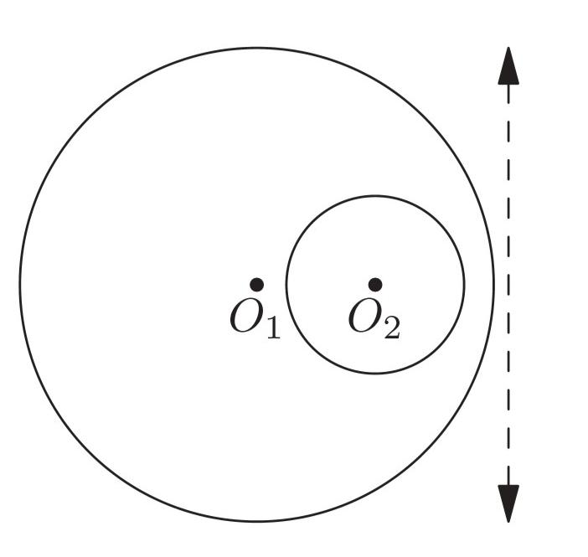
Detailed Explanation and Examples
Definition: An inner figure lies completely inside an outer figure but is displaced from its center or another natural reference point.
Example: A circle of radius $2$units lies entirely inside a circle of radius $5$units, but their centers differ.
The total area of the outer disk is $25π$, and the inner disk's area is $4π$.
The area inside the outer disk but outside the inner disk is
$$A=25π-4π=\boxed{21π}.$$
This subtraction is valid because the smaller disk is completely contained within the larger disk.

4. Inscribed-Figure Composition
# Source: AI Source: Provided by: [Data Path: Persons Table -> ID Column: 1, Name_En Column: Motasem Essam] -> From: [ChatGPT] on [7/25/2026]
The vertices of an inner polygon lie on the boundary of an outer circle, or an inner figure meets a boundary according to an inscribed configuration.
Example: A triangle inscribed in a circle, with all three vertices on the circle.
Detailed Explanation and Examples
Definition: A figure is inscribed in another figure when its vertices or boundary satisfy a specified boundary-contact relationship with the enclosing figure.
Example: An equilateral triangle is inscribed in a circle of radius $R$, so all three vertices lie on the circle.
The side length of the triangle is
$$s=\sqrt{3}R.$$
Its area is
$$A_{△}=\frac{\sqrt{3}}{4}s^{2}=\boxed{\frac{3\sqrt{3}}{4}R^{2}}.$$
The circle contains the triangle, and the triangle's vertices lie on the circle's circumference.

5. Circumscribed-Outer-Figure Composition
# Source: AI Source: Provided by: [Data Path: Persons Table -> ID Column: 1, Name_En Column: Motasem Essam] -> From: [ChatGPT] on [7/25/2026]
The outer figure surrounds an inner figure, with the inner figure touching its boundary at specified points.
Example: A circle inscribed in a square, tangent to all four sides.
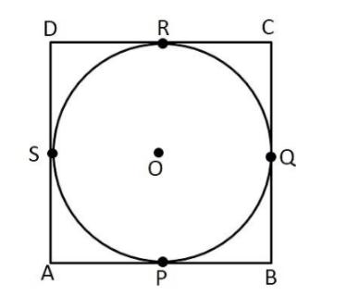
Detailed Explanation and Examples
Definition: An outer figure surrounds an inner figure, with the inner figure touching the outer boundary at specified points. In the common polygonal case, the outer polygon is circumscribed about the inner circle.
Example: A circle of radius $3$units is inscribed in a square. The circle touches all four sides.
The square's side length equals the circle's diameter:
$$s=2r=6.$$
The area inside the square but outside the circle is
$$A=s^{2}-πr^{2}$$
$$A=36-9π.$$
Therefore,
$$\boxed{A=36-9π}$$
square units.

6. Multiple-Level Nested-Figure Composition
# Source: AI Source: Provided by: [Data Path: Persons Table -> ID Column: 1, Name_En Column: Motasem Essam] -> From: [ChatGPT] on [7/25/2026]
Several figures are nested in a sequence, with each contained inside the next.
Example: A small square inside a medium square, which is inside a larger square.
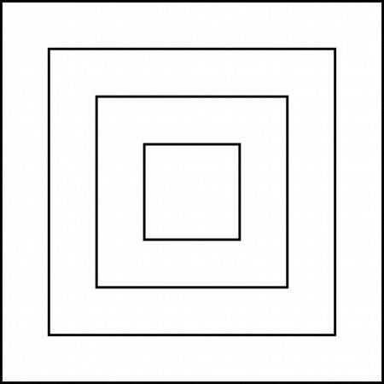
Detailed Explanation and Examples
Definition: Three or more figures are arranged in a containment hierarchy, with each successive figure lying inside another.
Example: Three nested squares have side lengths $12$, $8$, and $4$units.
The area between the largest and middle squares is
$$A_{1}={12}^{2}-8^{2}=80.$$
The area between the middle and smallest squares is
$$A_{2}=8^{2}-4^{2}=48.$$
The combined area outside the smallest square but inside the largest is
$$A_{\text{total}}=80+48=\boxed{128}$$
square units.

7. Mixed-Shape Nested-Figure Composition
# Source: AI Source: Provided by: [Data Path: Persons Table -> ID Column: 1, Name_En Column: Motasem Essam] -> From: [ChatGPT] on [7/25/2026]
Different types of figures are nested inside one another.
Example: A circle inside a square, with a triangle inside the circle.
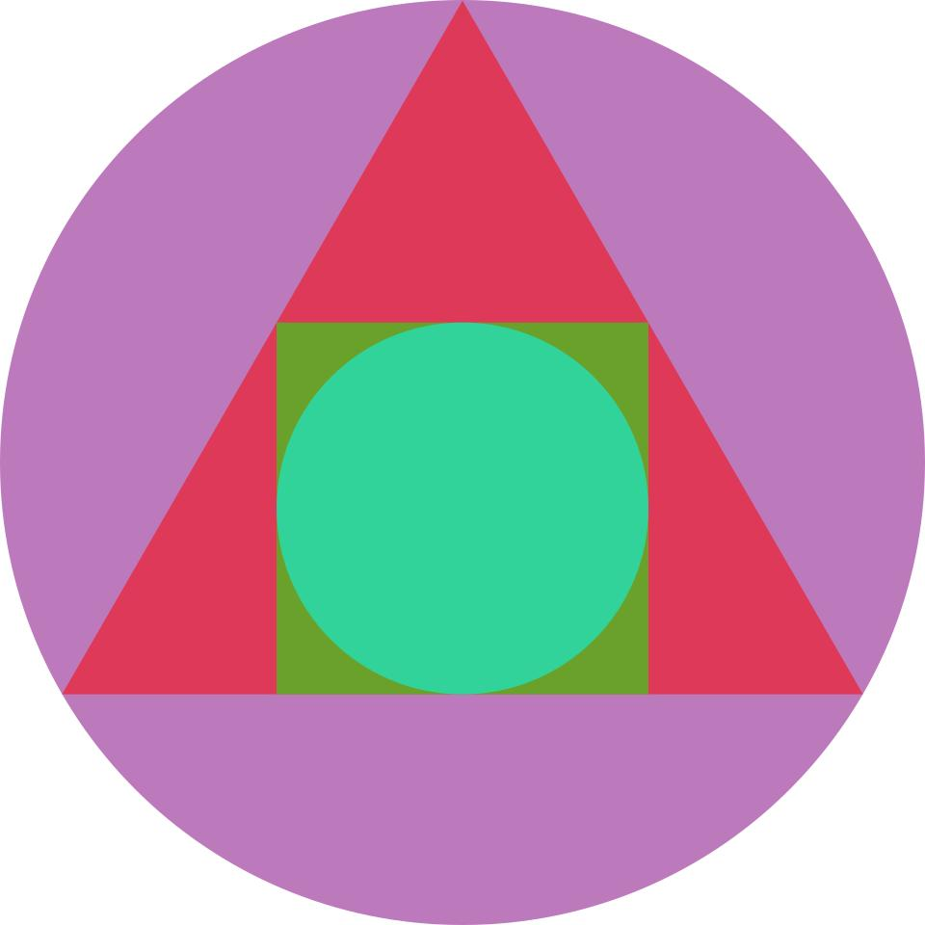
Detailed Explanation and Examples
Definition: Two or more different shape types are contained within one another.
Example: A circle is contained inside a square, and a triangle is contained inside the circle.
If the square has side length $s$and the circle has radius $r$, the area inside the square but outside the circle is
$$A_{1}=s^{2}-πr^{2}.$$
If the triangle lies entirely inside the circle, the area inside the circle but outside the triangle is
$$A_{2}=πr^{2}-A_{△}.$$
These formulas calculate different nested regions, provided the containment relationships hold.

8. Nested-Region Composition
# Source: AI Source: Provided by: [Data Path: Persons Table -> ID Column: 1, Name_En Column: Motasem Essam] -> From: [ChatGPT] on [7/25/2026]
The focus is on the region between an inner figure and its surrounding outer figure.
Example: The annular region between two concentric circles.
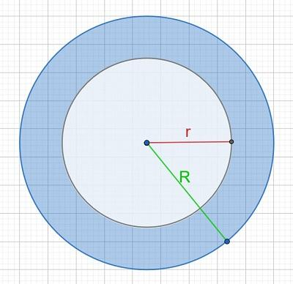
Detailed Explanation and Examples
Definition: A configuration in which the primary object of interest is the region between nested figures.
Example: Two concentric circles have outer radius $R=7$and inner radius $r=3$units.
The region between them is an annulus.
$$A_{\text{annulus}}=πR^{2}-πr^{2}$$
$$A_{\text{annulus}}=π\left(49-9\right)=\boxed{40π}$$
square units.
The annulus is the region between the two circular boundaries, not either disk individually.

Important Mathematical Principles

4.1. Containment
# Source: AI Source: Provided by: [Data Path: Persons Table -> ID Column: 1, Name_En Column: Motasem Essam] -> From: [ChatGPT] on [7/25/2026]
If a figure $B$lies entirely inside a figure $A$, then
$$B⊆A.$$
For example, if a disk lies inside a square, every point of the disk also belongs to the square.

4.2. Area of the Surrounding Region
# Source: AI Source: Provided by: [Data Path: Persons Table -> ID Column: 1, Name_En Column: Motasem Essam] -> From: [ChatGPT] on [7/25/2026]
When an inner region $B$is contained in an outer region $A$, the area outside the inner region but inside the outer region is
$$\boxed{Area⁡\left(A∖B\right)=Area⁡\left(A\right)-Area⁡\left(B\right)}.$$
This formula assumes the inner region is entirely contained in the outer region.

4.3. Nested Figures and Boundaries
# Source: AI Source: Provided by: [Data Path: Persons Table -> ID Column: 1, Name_En Column: Motasem Essam] -> From: [ChatGPT] on [7/25/2026]
Nesting does not necessarily mean that two boundaries touch.
- Strict containment: The inner figure lies entirely within the outer figure without touching its boundary.
- Boundary-touching containment: The inner figure touches the outer boundary at one or more points.
- Inscribed configuration: The inner figure satisfies a specified boundary-contact condition, such as all vertices of an inscribed polygon lying on a circle.

4.4. Nested Figures and Overlapping Figures
# Source: AI Source: Provided by: [Data Path: Persons Table -> ID Column: 1, Name_En Column: Motasem Essam] -> From: [ChatGPT] on [7/25/2026]
A figure completely contained in another has a special positional relationship. In set theory, the inner figure is a subset of the outer figure, but it is often more useful to classify this arrangement as containment or nesting rather than partial overlap.

Nested-Figure Composition vs. Related Concepts
# Source: AI Source: Provided by: [Data Path: Persons Table -> ID Column: 1, Name_En Column: Motasem Essam] -> From: [ChatGPT] on [7/25/2026]
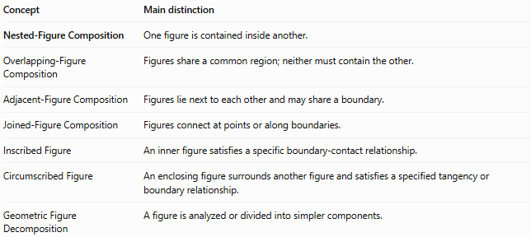
Concept | Main distinction
Nested-Figure Composition | One figure is contained inside another.
Overlapping-Figure Composition | Figures share a common region; neither must contain the other.
Adjacent-Figure Composition | Figures lie next to each other and may share a boundary.
Joined-Figure Composition | Figures connect at points or along boundaries.
Inscribed Figure | An inner figure satisfies a specific boundary-contact relationship.
Circumscribed Figure | An enclosing figure surrounds another figure and satisfies a specified tangency or boundary relationship.
Geometric Figure Decomposition | A figure is analyzed or divided into simpler components.

Classification Summary
# Source: AI Source: Provided by: [Data Path: Persons Table -> ID Column: 1, Name_En Column: Motasem Essam] -> From: [ChatGPT] on [7/25/2026]
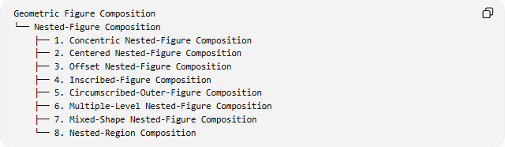
Geometric Figure Composition
└── Nested-Figure Composition
├── 1. Concentric Nested-Figure Composition
├── 2. Centered Nested-Figure Composition
├── 3. Offset Nested-Figure Composition
├── 4. Inscribed-Figure Composition
├── 5. Circumscribed-Outer-Figure Composition
├── 6. Multiple-Level Nested-Figure Composition
├── 7. Mixed-Shape Nested-Figure Composition
└── 8. Nested-Region Composition
This is a practical descriptive classification, not a universal formal taxonomy. The categories can overlap: for example, concentric circles are also a multiple-level nested configuration.

Key Points
# Source: AI Source: Provided by: [Data Path: Persons Table -> ID Column: 1, Name_En Column: Motasem Essam] -> From: [ChatGPT] on [7/25/2026]
- Nested figures have an inner-and-outer containment relationship.
- The figures may be concentric, centered, or offset.
- An inner figure may touch the outer boundary or remain separated from it.
- Inscribed and circumscribed configurations have specific geometric boundary relationships.
- The area between nested regions is calculated by subtracting the inner area from the outer area.
- Nested-figure composition is particularly useful for annuli, margins, borders, and composite-area problems.

Conclusion
# Source: AI Source: Provided by: [Data Path: Persons Table -> ID Column: 1, Name_En Column: Motasem Essam] -> From: [ChatGPT] on [7/25/2026]
Nested-Figure Composition describes geometric configurations in which one or more figures lie inside another figure. It is useful for studying containment, inscribed and circumscribed shapes, concentric configurations, and regions between boundaries. Its central mathematical idea is the relationship between an enclosing region and the smaller regions contained within it.

